UNIVERSITY OF CALIFORNIA, DAVIS

BERKELEY • DAVIS • IRVINE • LOS ANGELES • RIVERSIDE • SAN DIEGO • SAN FRANCISCO SANTA BARBARA • SANTA CRUZ

DANIEL J. KLIEBENSTEIN
COLLEGE OF AGRICULTURAL AND DEPARTMENT OF PLANT SCIENCES
ENVIRONMENTAL SCIENCES ONE SHIELDS AVE.
AGRICULTURAL EXPERIMENT STATION DAVIS, CALIFORNIA 95616-8746
COOPERATIVE EXTENSION PHONE: 530-754-7775
FAX: 530-752-9659
E-MAIL: Kliebenstein@ucdavis.edu
May 11, 2018

Dear Editor,

We would like to respectfully appeal the original decision on our manuscript entitled “Crop domestication and pathogen virulence: Interactions of tomato and Botrytis genetic diversity” for possible inclusion into Nature Communications.
The original decision gave the following reasons for the decision that called into question the conclusions.

- Population structure was not applied in the GWA.
- The disease development was incorrectly phenotyped.

We have the following reasons for each point as to why we feel that we have been able to properly reply to the concerns, or alternatively where we feel that they were incorrect.

For point 1, we have rerun the GWA with a mixed model including population structure and shown that the exact same polygenic architecture is identified regardless of the model, and as such our novel observations on the architecture of the interaction are intact. This was to be expected as a number of papers have shown that mixed model with population structure does not influence the architecture with regards to GWA and in fact can create a significant false negative issue (Chan et al., 2011; Brachi et al., 2015; Kooke et al., 2016; Corwin and Kliebenstein, 2017). We would like to note that the novelty of this manuscript is in the general architecture of the interaction which has never been described or tested in any similar system in plants or animals that we know of.

We noticed that in the decision from the editor, there was a comment about novelty with regards to our previous work that we were unsure about, as it was not in any of the reviewer comments. In fact, they all commented on the novelty of the work. We think that this might arise from a common misperception. In our previous work, we showed the extent of quantitative variation in B. cinerea on Arabidopsis. In the current manuscript, we describe the polygenic nature of domestication-altered resistance to Botrytis in tomato. A common misperception is that quantitative variation equals polygenic, which is simply not true (Falconer and Mackay, 1996; Mackay, 2001; Mackay, 2009; Mackay, 2014). It is possible to be polygenic and qualitative as well as monogenic and quantitative. As such, we would respectfully like to argue that the previous work showing quantitative variation does not prove polygenic architecture. Further, it is possible to be polygenic with a few genes or polygenic with 100s of causal loci, and the two provide very different demographic models of breeding or disease control. As such, we feel that the observations about domestication are novel and new insights for the field as stated by multiple reviewers.

For point 2, there were concerns about the experimental design that seem to be coming from two avenues. The first concern is that the protocol is unable to provide any resolution on genetic variation in the plant-fungus interaction. In the response to reviewers, we explain how the experiment design allows us to rule out extensive technical error that could alternatively explain the observed patterns. A linked concern was on the inoculum density, described as low by one of the reviewers who questioned the accuracy of such a spore count given the size of our experiment. We have corrected an oversight in our writing and clarified that there was continuous agitation of the samples to ensure equal spore application across samples. Additionally, we would like to note that we have used this protocol for over 15 years and a search of Google Scholar found 1,320 papers in the literature that used this very same protocol albeit with some lab-to-lab variation in spore density (Figure 1). This includes papers on molecular mechanism and quantitative genetics in Arabidopsis (Denby et al., 2004; Kliebenstein et al., 2005; Rowe and Kliebenstein, 2007, 2008; Rowe et al., 2010; Windram et al., 2012; Trontin et al., 2014; Corwin et al., 2016b; Corwin et al., 2016a; Fordyce et al., 2018). As such, we feel that a protocol used in over 1,000 papers is likely to provide some true information.

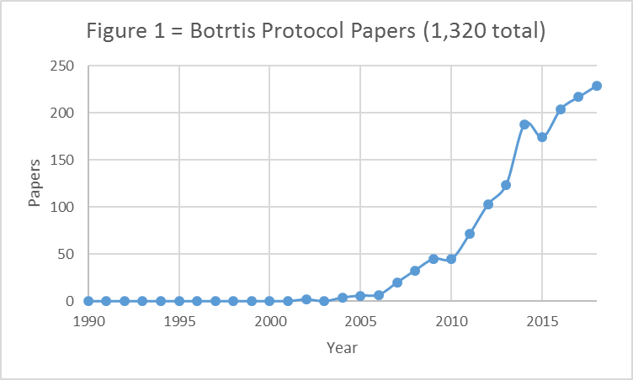

There was also a second conceptual concern surrounding point #2 and that seemed to be that we should ensure that development and resistance were explicitly partitioned in the experiment. However, this is contrary to the vast body of literature that is accumulating showing that development and defense are intricately intertwined at the mechanistic level with defense hormones controlling growth/development and growth/development hormones controlling defense. Further, in ecology and evolutionary theory, altering growth and development to evade a pathogen is the most effective resistance and MAMP/PAMP processes only play a role after the other methods fail. We were not trying to focus on specific molecular resistance mechanisms but instead focusing on the entirety of the host/pathogen interaction. We have worked to clarify this intent within the manuscript.

The above reasons are why we would respectfully request that you reassess your original decision on our manuscript.

Sincerely,



Daniel J Kliebenstein
Professor of Plant Genomics
University of California, Davis
Kliebenstein@ucdavis.edu

Brachi, B., Meyer, C.G., Villoutreix, R., Platt, A., Morton, T.C., Roux, F., and Bergelson, J. (2015). Coselected genes determine adaptive variation in herbivore resistance throughout the native range of Arabidopsis thaliana. Proceedings of the National Academy of Sciences of the United States of America 112, 4032-4037.
Chan, E.K., Rowe, H.C., Corwin, J.A., Joseph, B., and Kliebenstein, D.J. (2011). Combining genome-wide association mapping and transcriptional networks to identify novel genes controlling glucosinolates in Arabidopsis thaliana. PLoS Biol 9, e1001125.
Corwin, J.A., and Kliebenstein, D.J. (2017). Quantitative Resistance: More Than Just Perception of a Pathogen. Plant Cell 29, 655-665.
Corwin, J.A., Subedy, A., Eshbaugh, R., and Kliebenstein, D.J. (2016a). Expansive Phenotypic Landscape of Botrytis cinerea Shows Differential Contribution of Genetic Diversity and Plasticity. Molecular Plant-Microbe Interactions 29, 287-298.
Corwin, J.A., Copeland, D., Feusier, J., Subedy, A., Eshbaugh, R., Palmer, C., Maloof, J., and Kliebenstein, D.J. (2016b). The Quantitative Basis of the Arabidopsis Innate Immune System to Endemic Pathogens Depends on Pathogen Genetics. Plos Genetics 12.
Denby, K.J., Kumar, P., and Kliebenstein, D.J. (2004). Identification of Botrytis cinerea susceptibility loci in Arabidopsis thaliana. The Plant journal : for cell and molecular biology 38, 473-486.
Falconer, D.S., and Mackay, T.F.C. (1996). Introduction to Quantitative Genetics. (Essex: Longman, Harlow).
Fordyce, R.F., Soltis, N.E., Caseys, C., Gwinner, R., Corwin, J.A., Atwell, S., Copeland, d., Feusier, J., Subedy, A., Eshbaugh, R., and Kliebenstein, D. (2018). Combining Digital Imaging and Genome Wide Association Mapping to Dissect Uncharacterized Traits in Plant/Pathogen Interactions. bioRxiv.
Kliebenstein, D.J., Rowe, H.C., and Denby, K.J. (2005). Secondary metabolites influence Arabidopsis/Botrytis interactions: variation in host production and pathogen sensitivity. Plant Journal 44, 25-36.
Kooke, R., Kruijer, W., Bours, R., Becker, F., Kuhn, A., van de Geest, H., Buntjer, J., Doeswijk, T., Guerra, J., Bouwmeester, H., Vreugdenhil, D., and Keurentjes, J.J.B. (2016). Genome-Wide Association Mapping and Genomic Prediction Elucidate the Genetic Architecture of Morphological Traits in Arabidopsis. Plant physiology 170, 2187-2203.
Mackay, T.F.C. (2001). The genetic architecture of quantitative traits. Annual Review Of Genetics 35, 303-339.
Mackay, T.F.C. (2009). Q&A: Genetic analysis of quantitative traits. Journal of Biology 8, 23.
Mackay, T.F.C. (2014). Epistasis and quantitative traits: using model organisms to study gene-gene interactions. Nature Reviews Genetics 15, 22-33.
Rowe, H.C., and Kliebenstein, D.J. (2007). Elevated genetic variation within virulence-associated Botrytis cinerea polygalacturonase loci. Molecular Plant-Microbe Interactions 20, 1126-1137.
Rowe, H.C., and Kliebenstein, D.J. (2008). Complex genetics control natural variation in Arabidopsis thaliana resistance to Botrytis cinerea. Genetics 180, 2237-2250.
Rowe, H.C., Walley, J.W., Corwin, J., Chan, E.K.-F., Dehesh, K., and Kliebenstein, D.J. (2010). Deficiencies in jasmonate-mediated plant defense reveal quantitative variation in Botrytis cinerea pathogenesis. PLoS Pathogens 6, e1000861.
Trontin, C., Kiani, S., Corwin, J.A., Hematy, K., Yansouni, J., Kliebenstein, D.J., and Loudet, O. (2014). A pair of receptor-like kinases is responsible for natural variation in shoot growth response to mannitol treatment in Arabidopsis thaliana. Plant Journal 78, 121-133.
Windram, O., Madhou, P., McHattie, S., Hill, C., Hickman, R., Cooke, E., Jenkins, D.J., Penfold, C.A., Baxter, L., Breeze, E., Kiddle, S.J., Rhodes, J., Atwell, S., Kliebenstein, D.J., Kim, Y.S., Stegle, O., Borgwardt, K., Zhang, C.J., Tabrett, A., Legaie, R., Moore, J., Finkenstadt, B., Wild, D.L., Mead, A., Rand, D., Beynon, J., Ott, S., Buchanan-Wollaston, V., and Denby, K.J. (2012). Arabidopsis Defense against Botrytis cinerea: Chronology and Regulation Deciphered by High-Resolution Temporal Transcriptomic Analysis. Plant Cell 24, 3530-3557.

